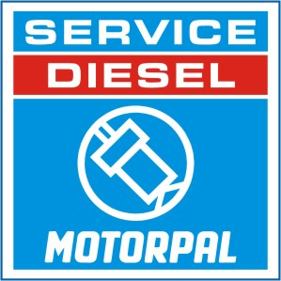

SERVICE DIESEL MOTORPAL

Explanations

Busines representative
C.S.
W.R.
M.f.
M.e.
PVA
M.i. V
PVB
B.R.
PVZ
PWZ
PC1
INJ
I.T.
E.C.
M.i.
M.i.M
M.j. V

Collection service – assembly and repair services will be conducted at the factory

Exhange center

Exhange repair

Implement training

In-line fuel injection pumps size Mj Vermi

In-line fuel injection pumps size Mi (Cummnins, Deutz, Greaves, Koel, Kukje, Zetor)

In-line fuel injection pumps size Mi Mercer (Deutz, Kukje, MMZ, Zetor)

In-line fuel injection pumps size Mi Vermi (Greaves, Zetor)

In-line fuel injection pumps size Mf (Avia, Cummnins, Deutz, Greaves, John Deere,

Koel, MAZ, MMZ, MTZ, Zetor)

In-line fuel injection pumps size Me (Avia, Zetor)

In-line fuel injection pumps size PV.A (Praga, Tatra)

In-line fuel injection pumps size PV.B (Liaz)

In-line fuel injection pumps size PV.Z (ČKD Hořovice, ČKD Hradec Králové, Issota,

UDMZ)

In-line fuel injection pumps size PW.Z (Belaz)

Single- cylinder fuel injection pumps size PC (Deutz, ČKD Hořovice,

ČKD Hradec Králové, Slavia Napajedla)

Injectors

Certificate - trained staff service

Service Contract - contract to provide service to the injection device Motorpal + training

SERVICE DIESEL MOTORPAL - UKRAINE

PVA
M.i.
W.R.
M.f.
M.e.
INJ
M.i.M
PP AVTORITM Certificate
B.R.
Mr. Teljuk Michal Nikolajevich Phone: +38 032 245 29 80
Volya-Bartatovskaya St. Fax: +38 032 245 29 81
Lvov region Mobile: +38 050 586 49 48
Gorodotsky district E-mail: tmm_service@mail.ru
UKRAINE www.
ПП АВТОРИТМ Certificate
B.R.
Телиюк Михал Николаевич Тел.: +38 032 245 29 80
Львовская область Факс.: +38 032 245 29 81
Городоцкий район Моб.: +38 050 586 49 48
ул. Воля-Бартатовская E-mail: tmm_service@mail.ru
УКРАИНА www.

